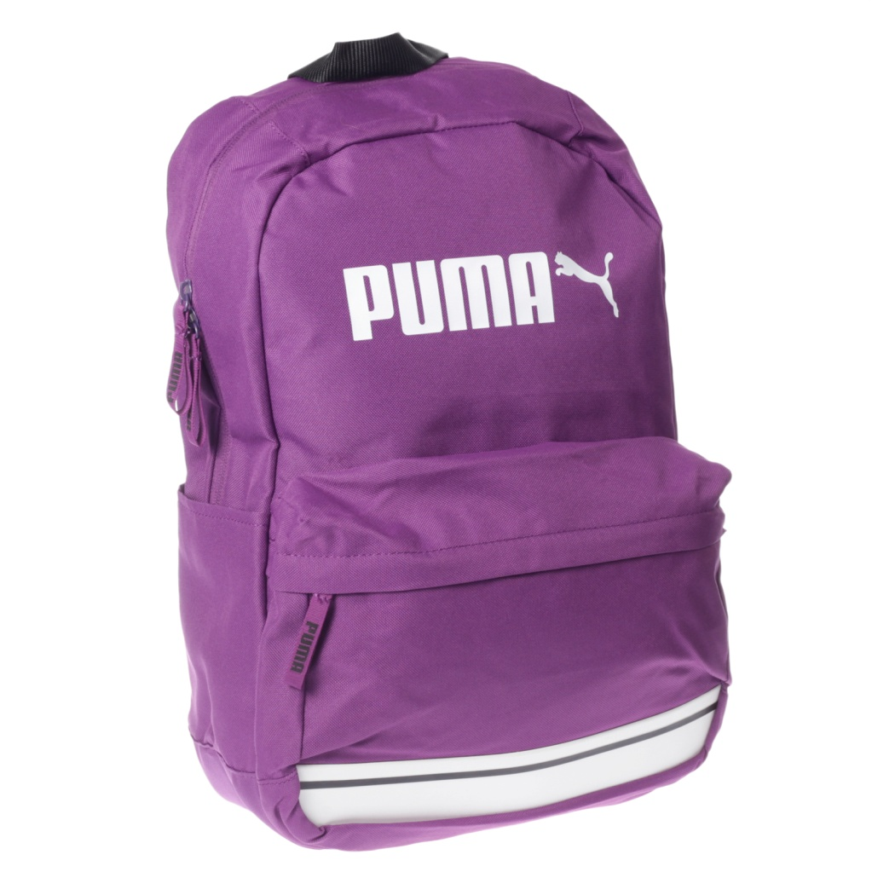

# PUMA PURPLE -012

|  |  |
| --- | --- |
| BRAND | PUMA |
| ITEM DIMENSION | 2 x 4 x 12.13inches |
| MODEL NAME | 012 |
| COLOR | PURPLE |
| PRICE | **RS 1350** |